**Tessa Davis**

**Foundations of Programming-Python**

**Assignment 06**

**March 2022**

**Module 06 Knowledge Document**

**Assignment**

This assignment was focused on learning how to define and work with functions. We were also introduced to the concept of classes and local vs global variables in functions. A theme of the week seemed to be on increasing our skills in creating and commenting code that is intelligible to others, intelligible to your future self, and the role functions play in that effort, as well as in creating efficient code.

**Discussion**

Intro to Functions material

It is surprising to me (so I note it here for future reference) that the arguments put into functions need not necessarily match the values that will be pulled (e.g. the Hitchhiker function pulled ‘srtData’ as the first value with the argument ‘message’). I accept that, as I have seen it work repeatedly, and think it speaks to the difference between a parameter and an argument. But, because they are sometimes used interchangeably, I still find myself a bit uncomfortable with the terminology.

Lab 06-A

By adding the ‘Call the Function’ block of code, I defined the variables therein as the results of the call of the functions with the user data input collected by the prior block of code. This block actually ran the basic math and assigned the value to each respective variable. I then modified the display block to print the variables (sum, diff, pro, and quo), keeping the running of the functions out of this block and limited to the prior block. I am still not sure I fully see the value of this structure but I believe it is that if I wanted to run and or display the results of calling the function further on in the code I would not have to call the function but could just display the value. That would, I believe, save computing power.

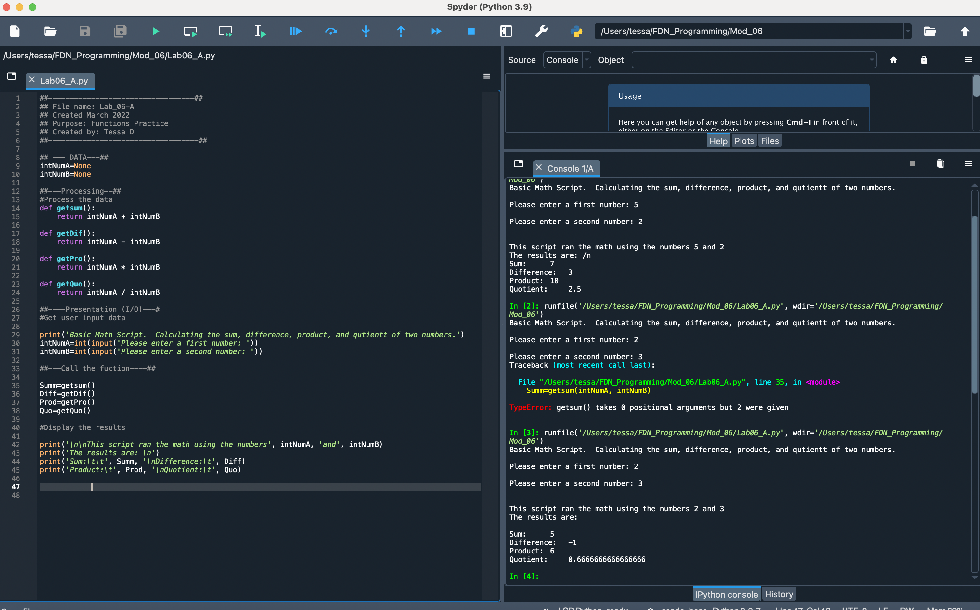

Figure Lab 06-A

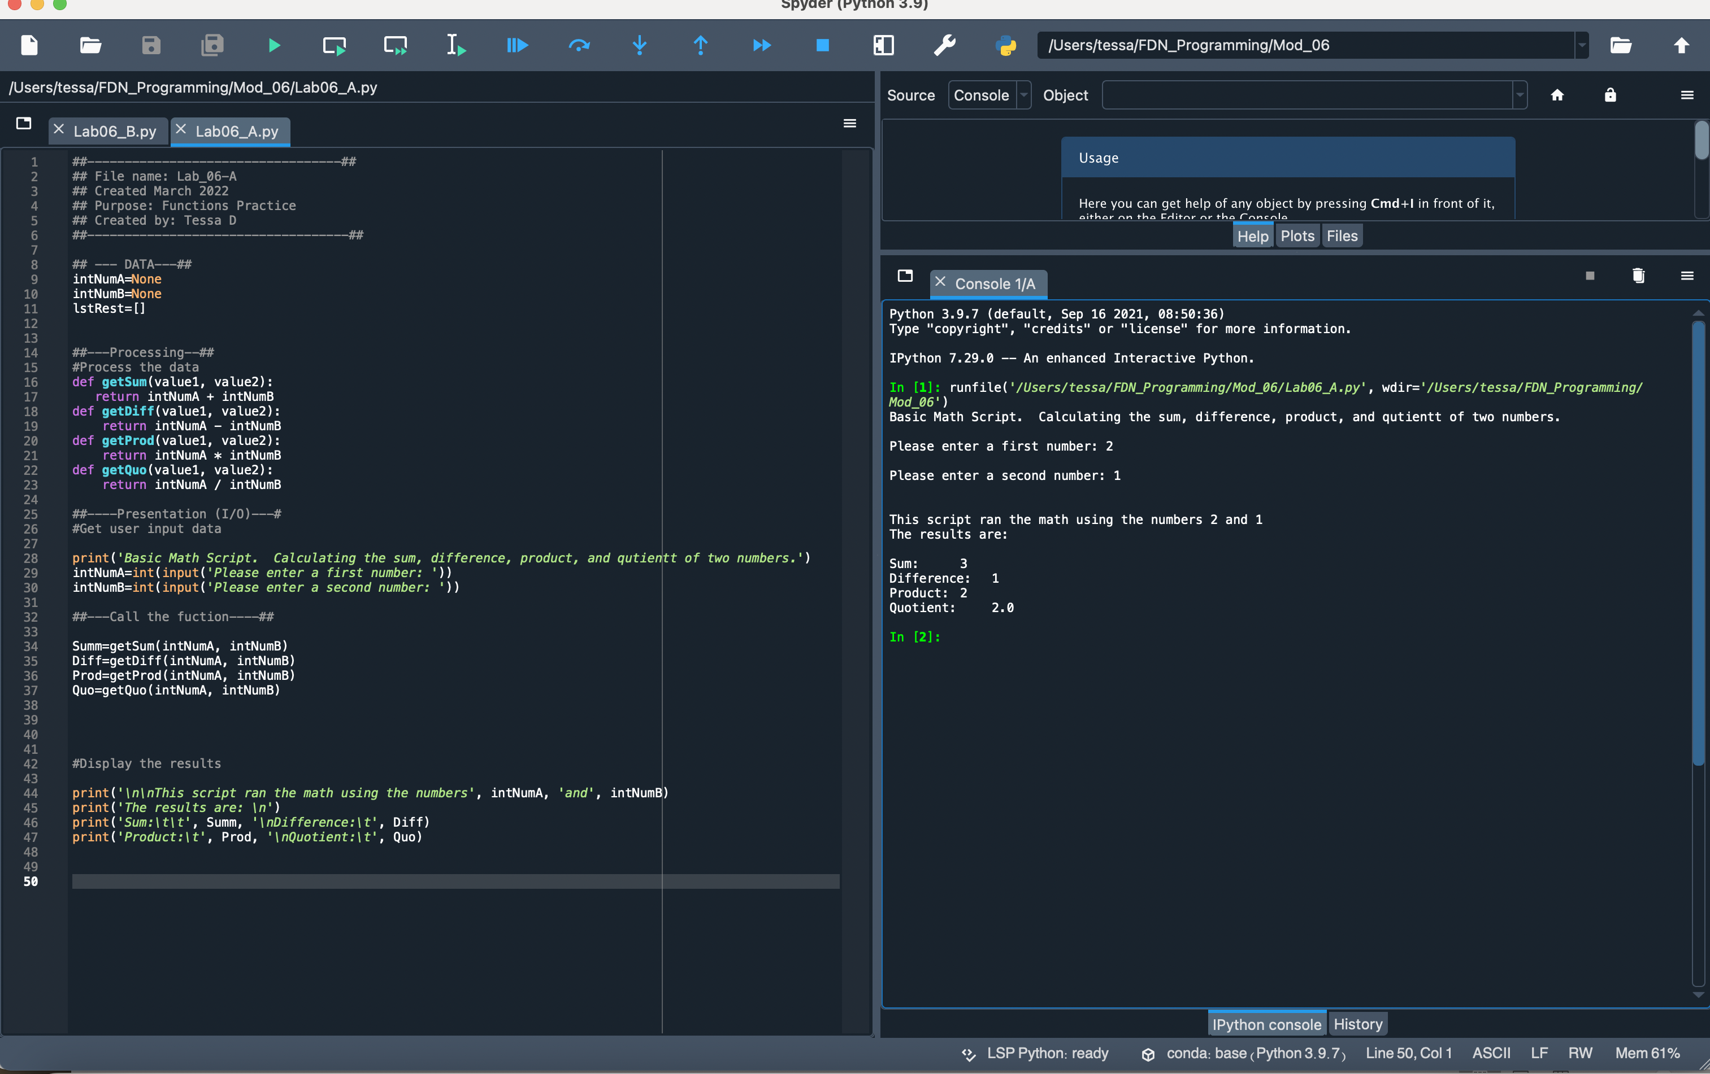

Figure Modified Lab06-A

Lab 06-B

This lab felt fairly intuitive. I also appreciated the practice with unpacking a list using indices as I am still working on understanding when it makes sense to use indices and the role they play.

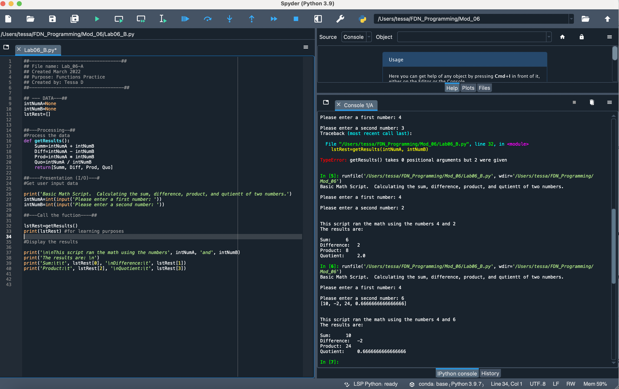

Figure Lab06-B

Lab 06-C Classes

Classes made perfect sense to me and (I think) helped me clarify the role of methods (am I correct in thinking that the function works as a method within the class? or is that confusing different concepts?)

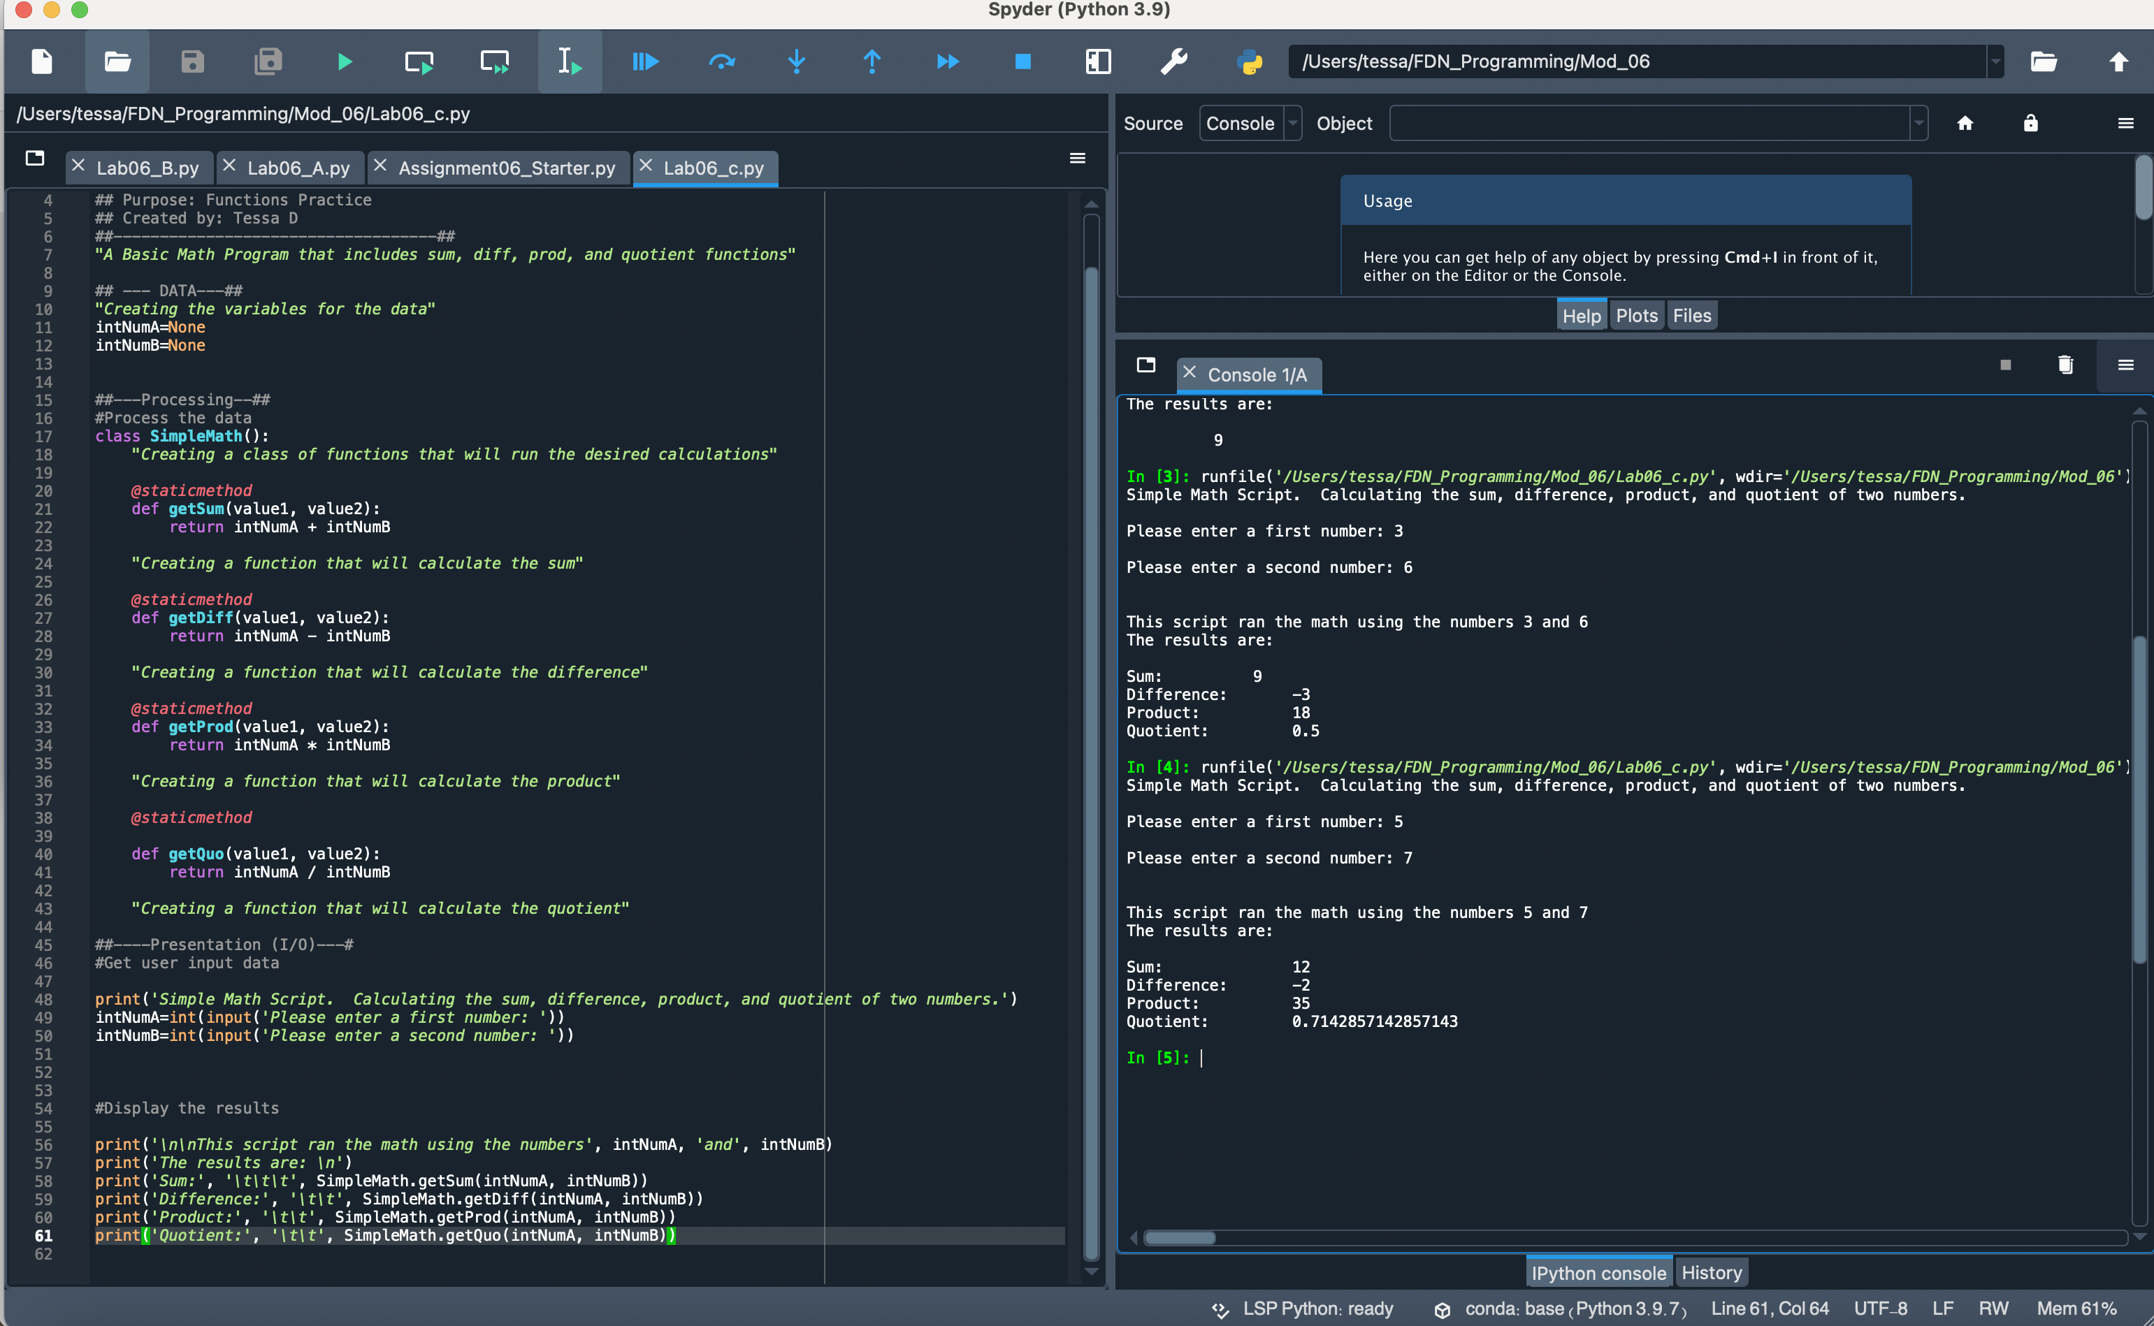

Figure Lab 06-C Spyder Screenshot

Assignment 06

The assignment felt like a significant step up from the labs. At first, I struggled with getting variables defined in the proper place (i.e. the local vs. global issue). My get_entry and create_entry functions took the bulk of the time to fix. What I had failed to properly do at the outside was pass the variables collected from get_entry into create_entry. As such, I was getting various errors as I struggled with how to solve the problem. I attempted, at one point, to pull lstRow into create_entry and use its index to define each aspect of dictRow in the function, but had failed to properly pass the get_entry into create_entry in the while loop. Once I solved the issue with create and get_entry, the subsequent functions fell into place.

Using the create_entry as an example, my understanding of how the function works is as follows: I define create_entry as a function under the class DataProcessor. By including the parameter (lstRow), I tell the function to expect one argument. The subsequent lines of code then work to break lstRow (when entered after the function is called) into its respective index values, assigning the values to intID (and convert to an integer), strTitle, and stArtist. Line 33 then defines dicRow as a dictionary of the preceding values, line 34 appends the table with dicRow and line 35 then calls the classIO function show_inventpory, feeding it the value of lstTbl. Down in the while loop, create_entry is called, being fed the lstRow created by the call of get_entry above. Other functions work similarly, varying in the number of arguments and/or tasks (e.g. get_entry, when called, collects user input and turns that input into a lstRow that it then returns). As I understand it, the parameters and arguments that need to be passed in are, in part, related to what you are asking the function to do. For instance, the print menu function requires no arguments as it simply displays a menu defined within the function. Conversely, write_file has to have the parameters of both file_name and table because it must work with both.

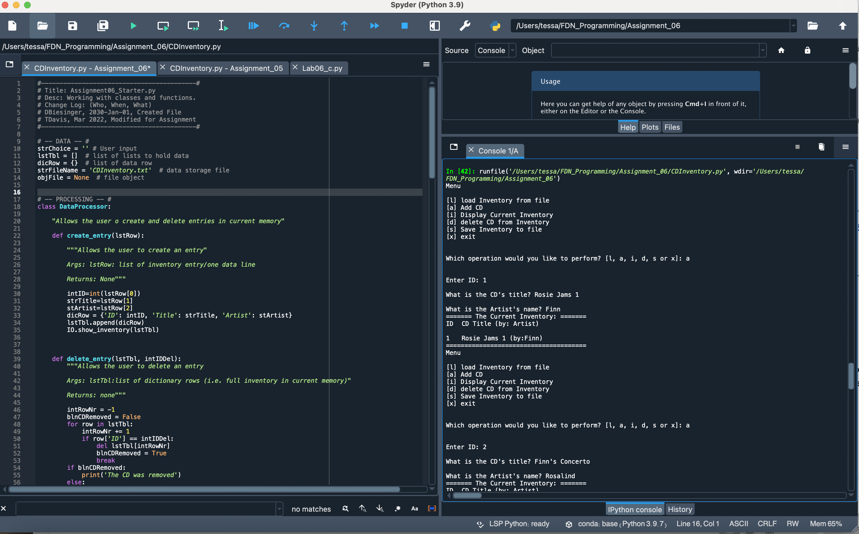

Figure Demonstrating 'a' function functionality

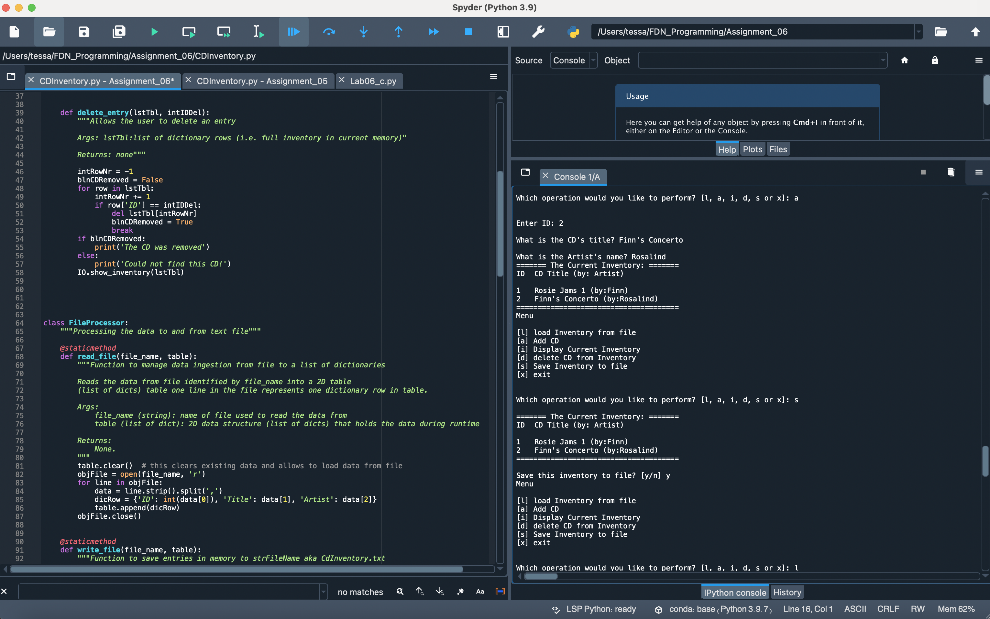

Figure Demonstrating 'a' and 's' functionality

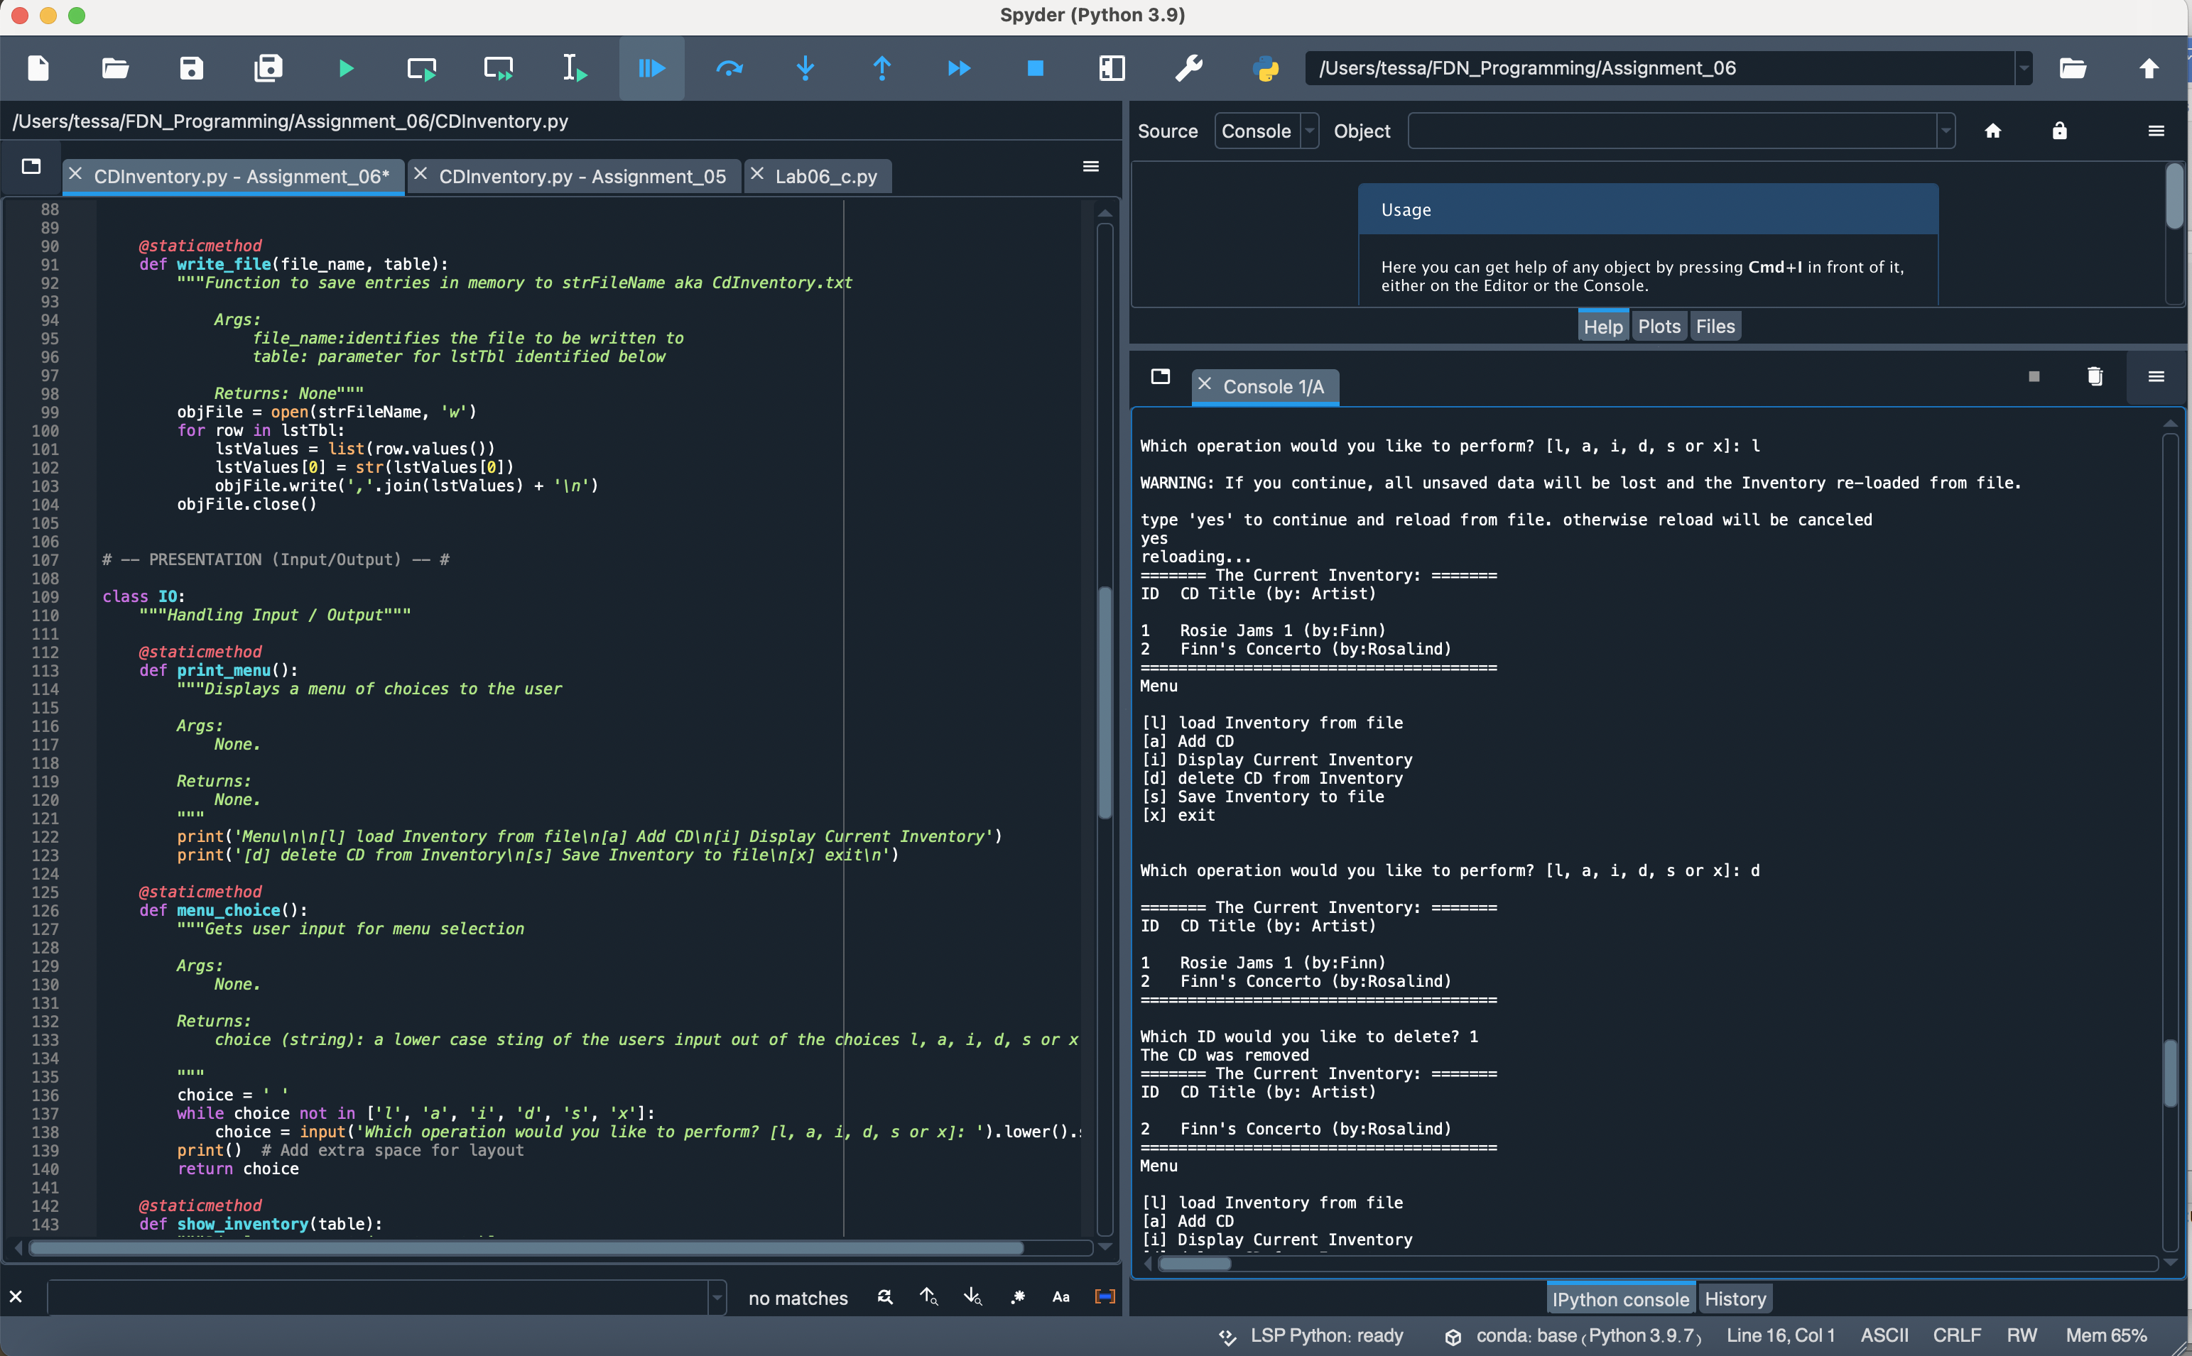

Figure Demonstrating 'l' and 'd' functionality

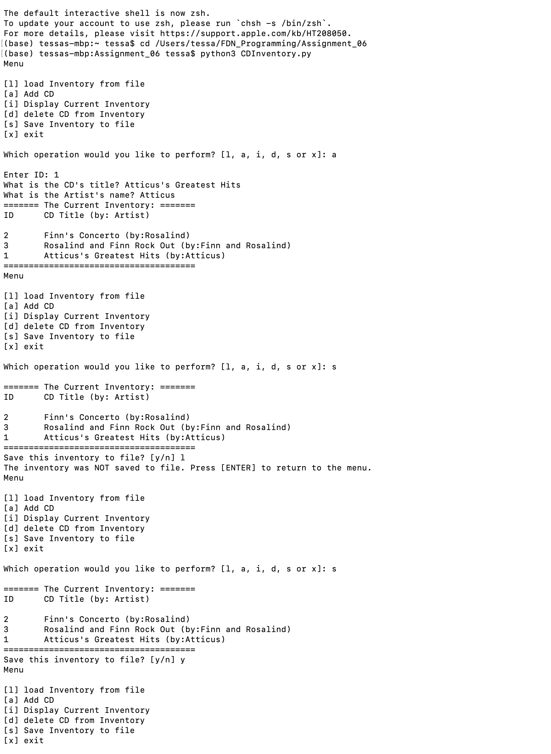

Figure Running in Terminal 1 of 3

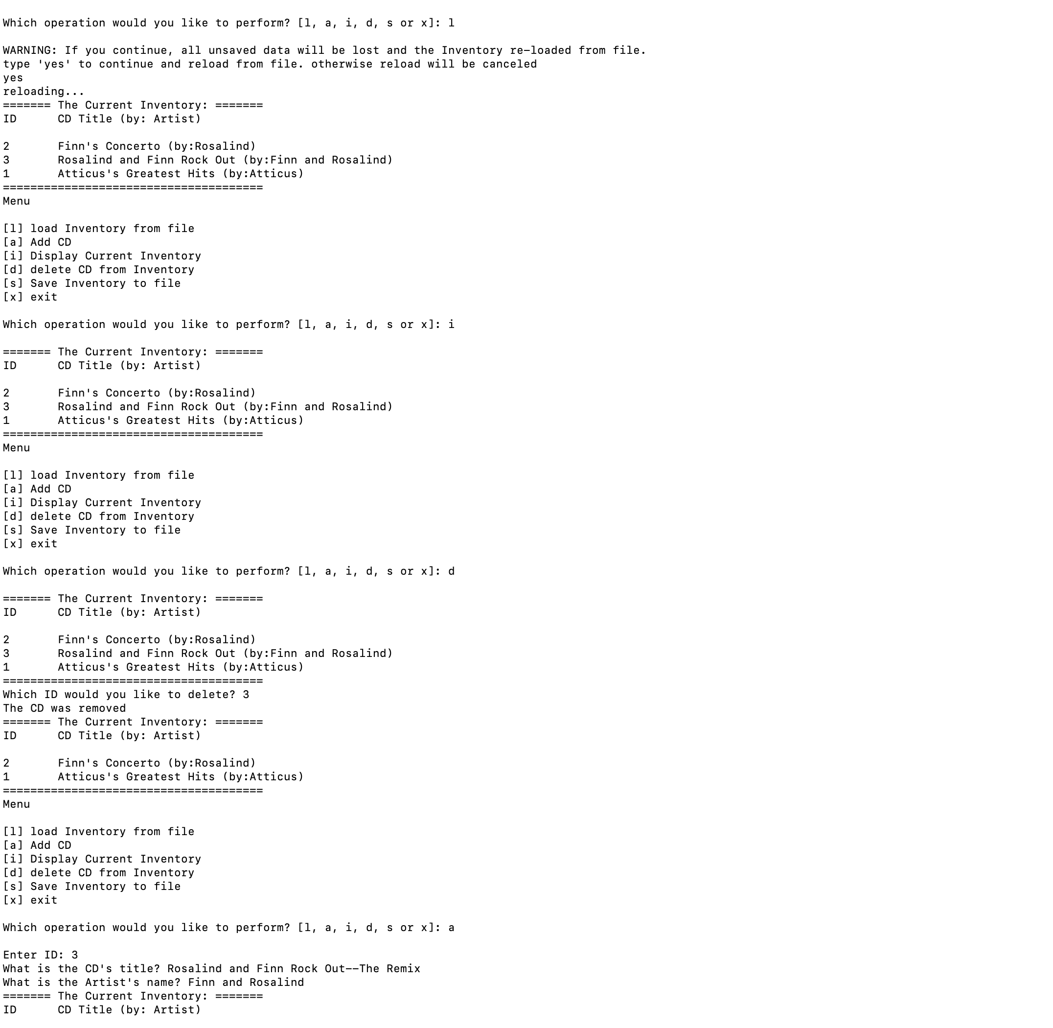

Figure Running in Terminal 2 of 3

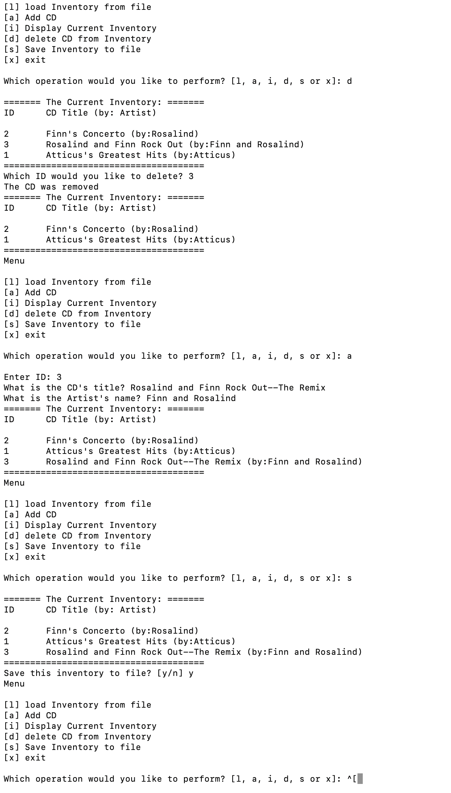

Figure Running in Terminal 3 of 3

**Conclusion**

While I can see improvement, these last few assignments have been very difficult. I can wrestle with the labs fairly easily, but when the scope of the work grows in the assignment, I run into struggle. I believe one of the lessons of this week was to see the difficulty of working with someone else’s code and comments. I think that slowed down my trouble shooting but I also believe the need to work with multiple parameters and variables to make the code work felt like a big step up from the labs. Trying to trust the process!